Create an internet-facing ALB in the public subnets of my-restaurant-vpc. The ALB routes traffic to the configured public subnets only. Traffic on different ports can be routed to different target groups created earlier. We are expecting traffic on port 80 alone in this exercise.

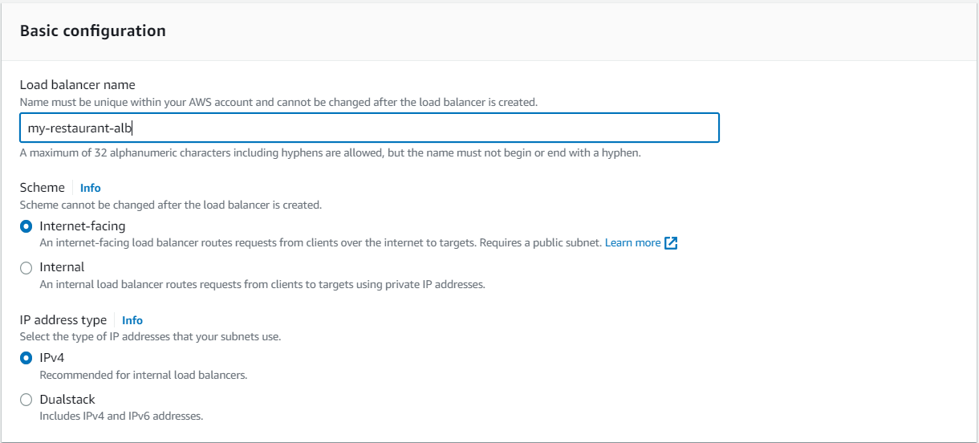

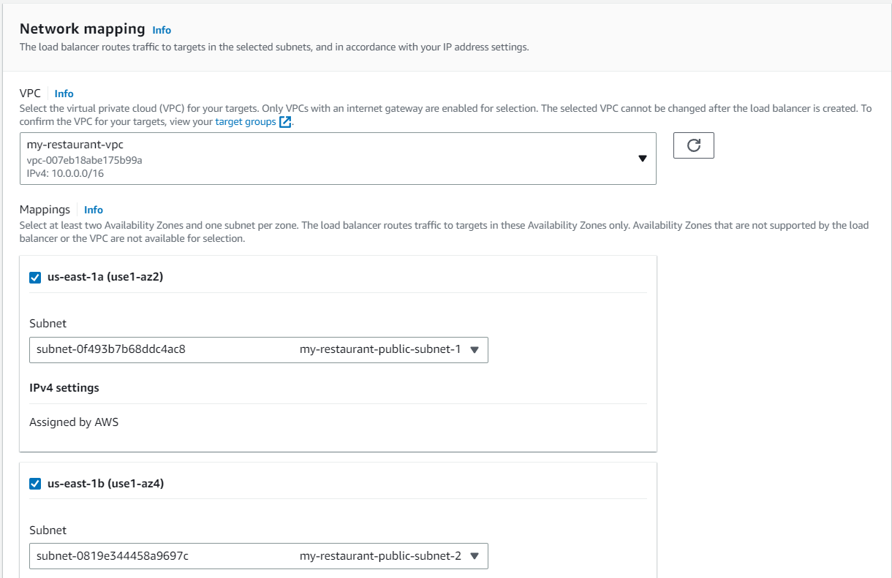

Ideally, create a separate security group for the load balancer that allows traffic on ports 80 and 443. We can use the my-restaurant-public-security-group, that was created for instances to be launched in the public subnet, because this security group also allows traffic on ports 80 and 443.

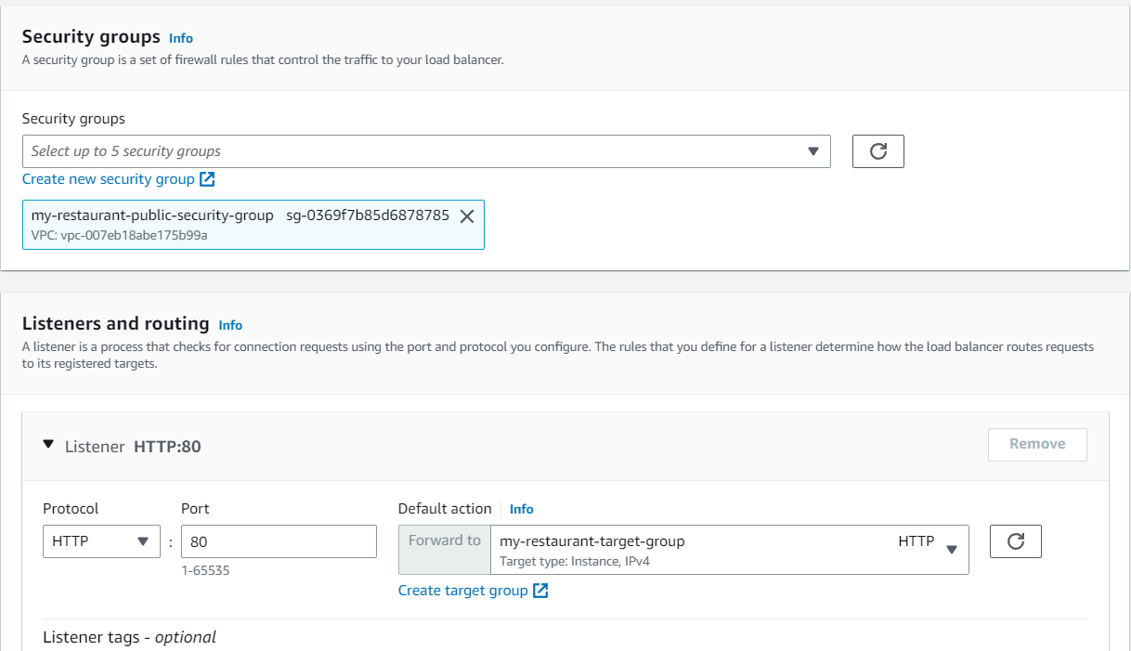

One important advantage of ALB over the Classic Load Balancer is the ability to route traffic to different target groups based on the port in which the traffic arrives.

Summarizing:

Target group has health check configured.

ALB has the VPC, Subnet details in which the instances need to be launched. ALB uses the Target group for health checks on the EC2 instances. The port information configured for ALB and target group must be in sync i.e. in the ALB, if you are saying traffic on port 80 must be routed to target-group-a, make sure the target-group-a is configured to accept traffic on port 80.